Assignment: Google Web Accessibility

Student: Exenreco Bell

Date: July18, 2024

# Focus

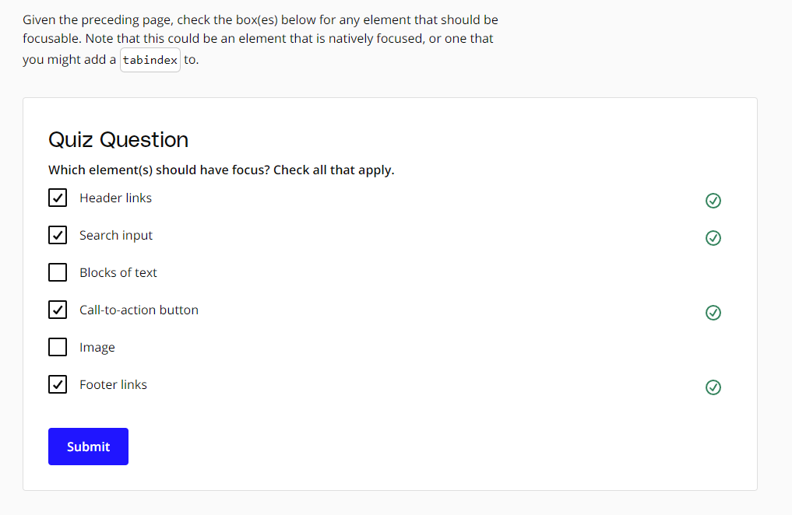

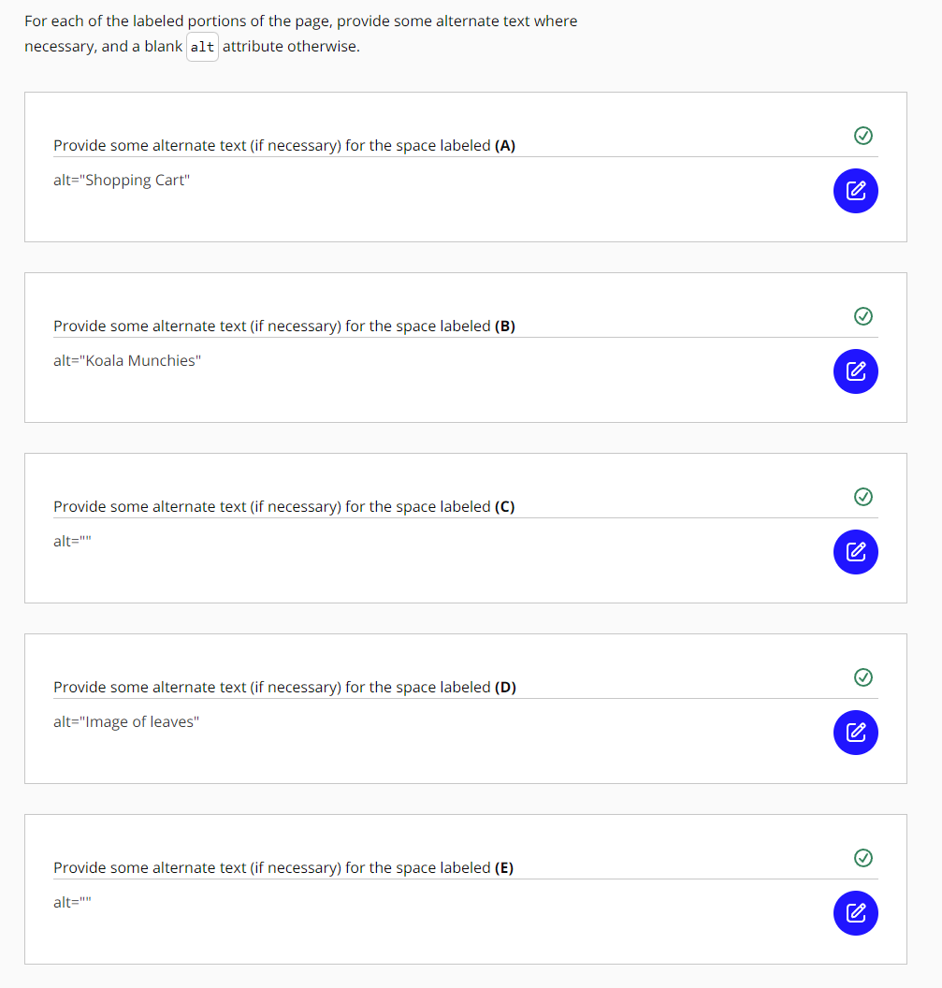

# Navigation Content

